COMPARATIVE STUDIES OF FLUID DYNAMIC GAUGING AND A MICROMANIPULATION PROBE FOR STRENGTH MEASUREMENTS

# R.J. Hooper1, W. Liu2, P.J. Fryer2, W.R. Paterson1*, D.I. Wilson1 & Z. Zhang2

1 *Department of Chemical Engineering, Pembroke St, Cambridge, CB2 3RA, UK.*

2 *Centre for Formulation Engineering, University of Birmingham, Birmingham, UK, B15 2TT*

## ABSTRACT

*Two measurement techniques have been developed independently at the Universities of Birmingham and Cambridge to determine the strength and deformation behaviour of soft solid fouling layers on hard surfaces immersed in liquid in real time. These micromanipulation and fluid dynamic gauging techniques were compared directly in parallel studies of removal of baked tomato purée deposits on stainless steel coupons. Both techniques showed marked and quantifiable effects of baking time and hydration time on removal behaviour of the deposits. Micromanipulation allowed adhesive and cohesive interactions to be explored separately, while the dynamic gauging tests showed changes in deformation mode resulting from differences in adhesive and cohesive strength. The two techniques displayed similar trends and complementary phenomenological detail. Direct quantitative comparison was not straightforward, as the gauging results exhibited noticeably greater scatter, partly because this is a more localised measurement.*

### INTRODUCTION

The forces required to disrupt or remove fouling deposits are rarely well understood, both because these are difficult to quantify and because they are determined by the removal mode, the age (and structure) of the deposit, and the nature of the deposit-surface interactions. Knowledge of such forces, sometimes termed ‘strengths’, has immediate application in fouling mitigation and cleaning, as process conditions or equipment configurations could then be designed so that the forces imposed by a cleaning solution, say, in a cleaning-in-place system would exceed those holding the deposit to the surface and thus promote its removal. Similarly, such knowledge would be a useful way to test the effectiveness of modified surfaces whose surface energies would result in weaker adhesive interactions with a deposit.

Direct measurement of the strength of fouling deposits on solid surfaces *in situ* and effectively *in vivo* has recently been demonstrated by the authors’ groups at Birmingham and Cambridge using two different physical techniques, namely micromanipulation and fluid dynamic gauging, respectively. Chew *et al*. (2004) presented a comparison of the two methods in a study of baked tomato paste on stainless steel surfaces. Chew *et al*. followed the protocol reported by Liu *et al*. (2002) for preparing deposits for micromanipulation, and reported a linear correlation between the parameters obtained using each method. In this work, the two techniques have been compared directly by testing identical fouling deposits in parallel, in the same laboratory. Tomato pastes were initially used as model deposit layers by Cheow and Jackson (1982).

Figure 1 illustrates the action of the two techniques. The micromanipulation technique employs *controlled strain*: a T-shaped probe is pulled across a horizontal circular plate at a constant height, removing the fouling deposit by a shovelling action. The system can be immersed in liquid, so that the deposit can be studied in its hydrated state, or in the presence of cleaning agents. The vertical position of the probe, *z*, can be controlled to micron accuracy, so that it can be set to disrupt the material at the substrate surface or within the deposit layer, allowing adhesive and cohesive interactions to be investigated, respectively. The force required to move the arm is measured and converted into an adhesion strength (work required to remove the deposit per unit area of the surface) via

 (1)

where *D* is the diameter of the coated disc and *F* the force measured at time *t*. A detailed description of the technique is given in Liu *et al*. (2002).

(*a*) (*b*)

*z*, adjustable

*x*

probe

deposit layer

substrate

force

transducer

Figure 1. Schematics of the principles of (*a*) micromanipulation and (*b*) fluid dynamic gauging

EXPERIMENTAL

*Sub-heading*

Text.

*Another sub-heading*

More text.

RESULTS AND DISCUSSION

*Subheading*

Text

More text, new paragraph

*Hydration time*

Text

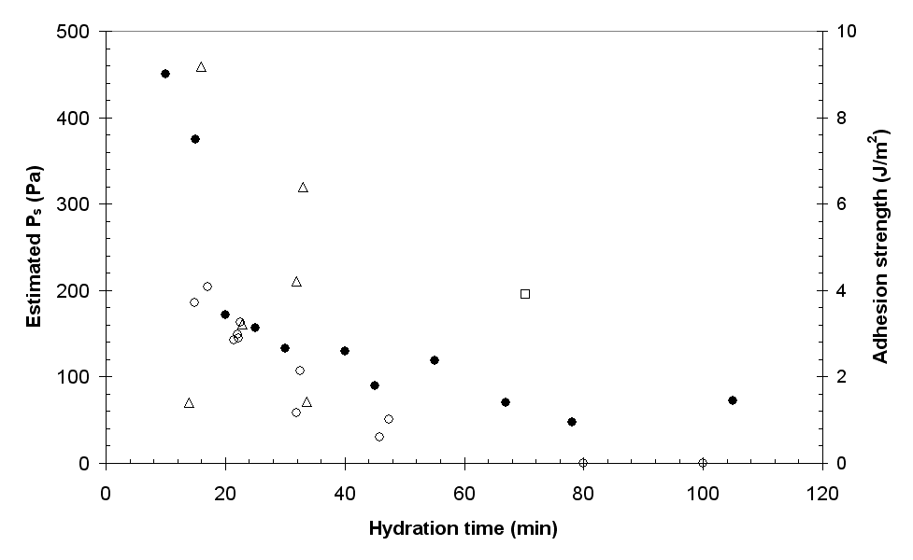

Figure 2. Effect of hydration time on the strength of tomato purée deposit indicated by micromanipulation and FDG (complete removal).

Symbols: solid circle, micromanipulation; open, FDG, with mode: circle - hole; triangle -bulge; square - lift. 60 minutes baking time.

Table 1 Caption above table.

|  |  |  |  |  |  |
| --- | --- | --- | --- | --- | --- |
|  | Duct flow mode, *Re* = 3300 | | | | |
| Deposit | # tests | ** | **R,A | **□   μm | time to swell,  s |
| Surface | 6 | 1.2 | - | 460 | 140 |
| G80 | 6 | 2.4 | 1.4 | 260 | 190 |
| G90 | 6 | 2.0 | 1.7 | 380 | 200 |

CONCLUSIONS

Text

ACKNOWLEDGEMENTS

A Bright Futures scholarship for RJH from the NZ government is gratefully acknowledged.

REFERENCES

Cheow, C.S. and Jackson, A.T. (1982) Circulation cleaning of a plate heat exchanger fouled by tomato juice, I. Cleaning with water, *J. Food Tech*., **17**, 417-430.

**PLEASE DO NOT INSERT PAGE NUMBERS**

**Please submit in Word or pdf format and email your full paper to:**

[y.m.chew@bath.ac.uk](mailto:y.m.chew@bath.ac.uk), [ian.wilson@ceb.cam.ac.uk](mailto:ian.wilson@ceb.cam.ac.uk) and <frank.lipnizki@chemeng.lth.se>