(1 empty line)
(1 empty line)
Proceedings Template for Articles to LU 2015
(1 empty line)
First A. Author, Second B. Author, and Third C. Author, Affiliation
(1 empty line)
(1 empty line)
ABSTRACT: The abstract should not exceed 250 words and it should briefly summarize the essence of the paper. The full paper should be prepared using this template, and submitted both in doc/docx and pdf format in high quality print. No hardcopy is required. Please do not insert page numbers and do not secure the pdf file.

General

Paper, authors and affiliation
Title format: 18pt Times New Roman, centre adjusted. Title longer than one line is preferable to split into a single-line title and a subtitle. Subtitle is 14pt Times New Roman.
Authors are listed with initials and last names, followed by the affiliation.

Paper size, margins and numbering
Please use page size A4. The text should fit exactly into the type area and be fully adjusted. Papers in two columns format will not be accepted. For A4 size paper the margin settings are: Top: 20 mm; Bottom: 20 mm; Inside: 25 mm; Outside: 25 mm. Table nn summarizes the margins applied.
Please do not insert page numbers.

Sections
The paper directly starts with the Abstract, followed by the consecutively numbered main chapters. Make sure you include methods, reflections and results. For further advice see the letter of acceptance. Include a list of references at the end of the manuscript.

Paper length, language and Submission
Paper length should be 1500-3000 words for presentations and 1000-2000 words for roundtables and podcasts.
Language of the paper shall be Swedish, Norwegian, Danish or English. Please proofread your paper.

Submission deadline and procedure
Please submit the full paper within the submission deadline Monday October 26. 2015, both in doc/docx and pdf format in high quality print to Lisbeth.Tempte@kansli.lth.se.
E-mail subject: LU-konferens 2015, fulltext.
Name of document should be as follows:
- One author: LastnameAuthor.doc/docx/pdf
- Two authors: Lastname1Author_Lastname2Author.doc/docx/pdf
- More than two authors: Lastname1Author_etal.doc/docx/pdf

SECTION HEADINGS, TEXT STYLE AND PROCEEDINGS

Heading 1
Format of section headings: bold capitals Times New Roman 11 pt. Line spacing before and after a heading is 12 pt and 6 pt, respectively. Use consecutive numbering of the sections. The References heading is not numbered.

Heading 2
Secondary headings are as Heading 1 but typed with initial capitals. Line spacing before and after a secondary heading is both 6 pt. Please limit the depth of headings to major and secondary headings.

Normal text style
The normal text is typed in Times New Roman 11 pt, adjusted with single line spacing. Line spacing between consecutive paragraphs within the same section is 6 pt as in this Template.

Proceedings from the conference
The articles will be printed for the conference delegates and made available online on the conference page on http://www.lth.se/genombrottet/utvecklingskonferens-lu2015. The printed proceedings will be in black and white, but the online articles will be as the original pdf (including colours).

Figures, tables and equations

Tables
Tables prepared in basic word format are preferred. Tables must be referred to in the text in the format as Table nn. The smallest font size in the table shall not be smaller than 10 pt.
Table nn. Margins of the page size A4 [mm]
top | bottom | inside | outside
20 | 20 | 25 | 25

Figures, diagrams, illustrations
Figures, diagrams, illustrations should have a resolution of 600 dpi. Reference to the figures must be given in the text. Two-column figure arrangement as shown in Fig. 1 and Fig. 2 is allowed: use 2x2 table without borders. The smallest font size in the figures shall not be smaller than 10 pt.

 | 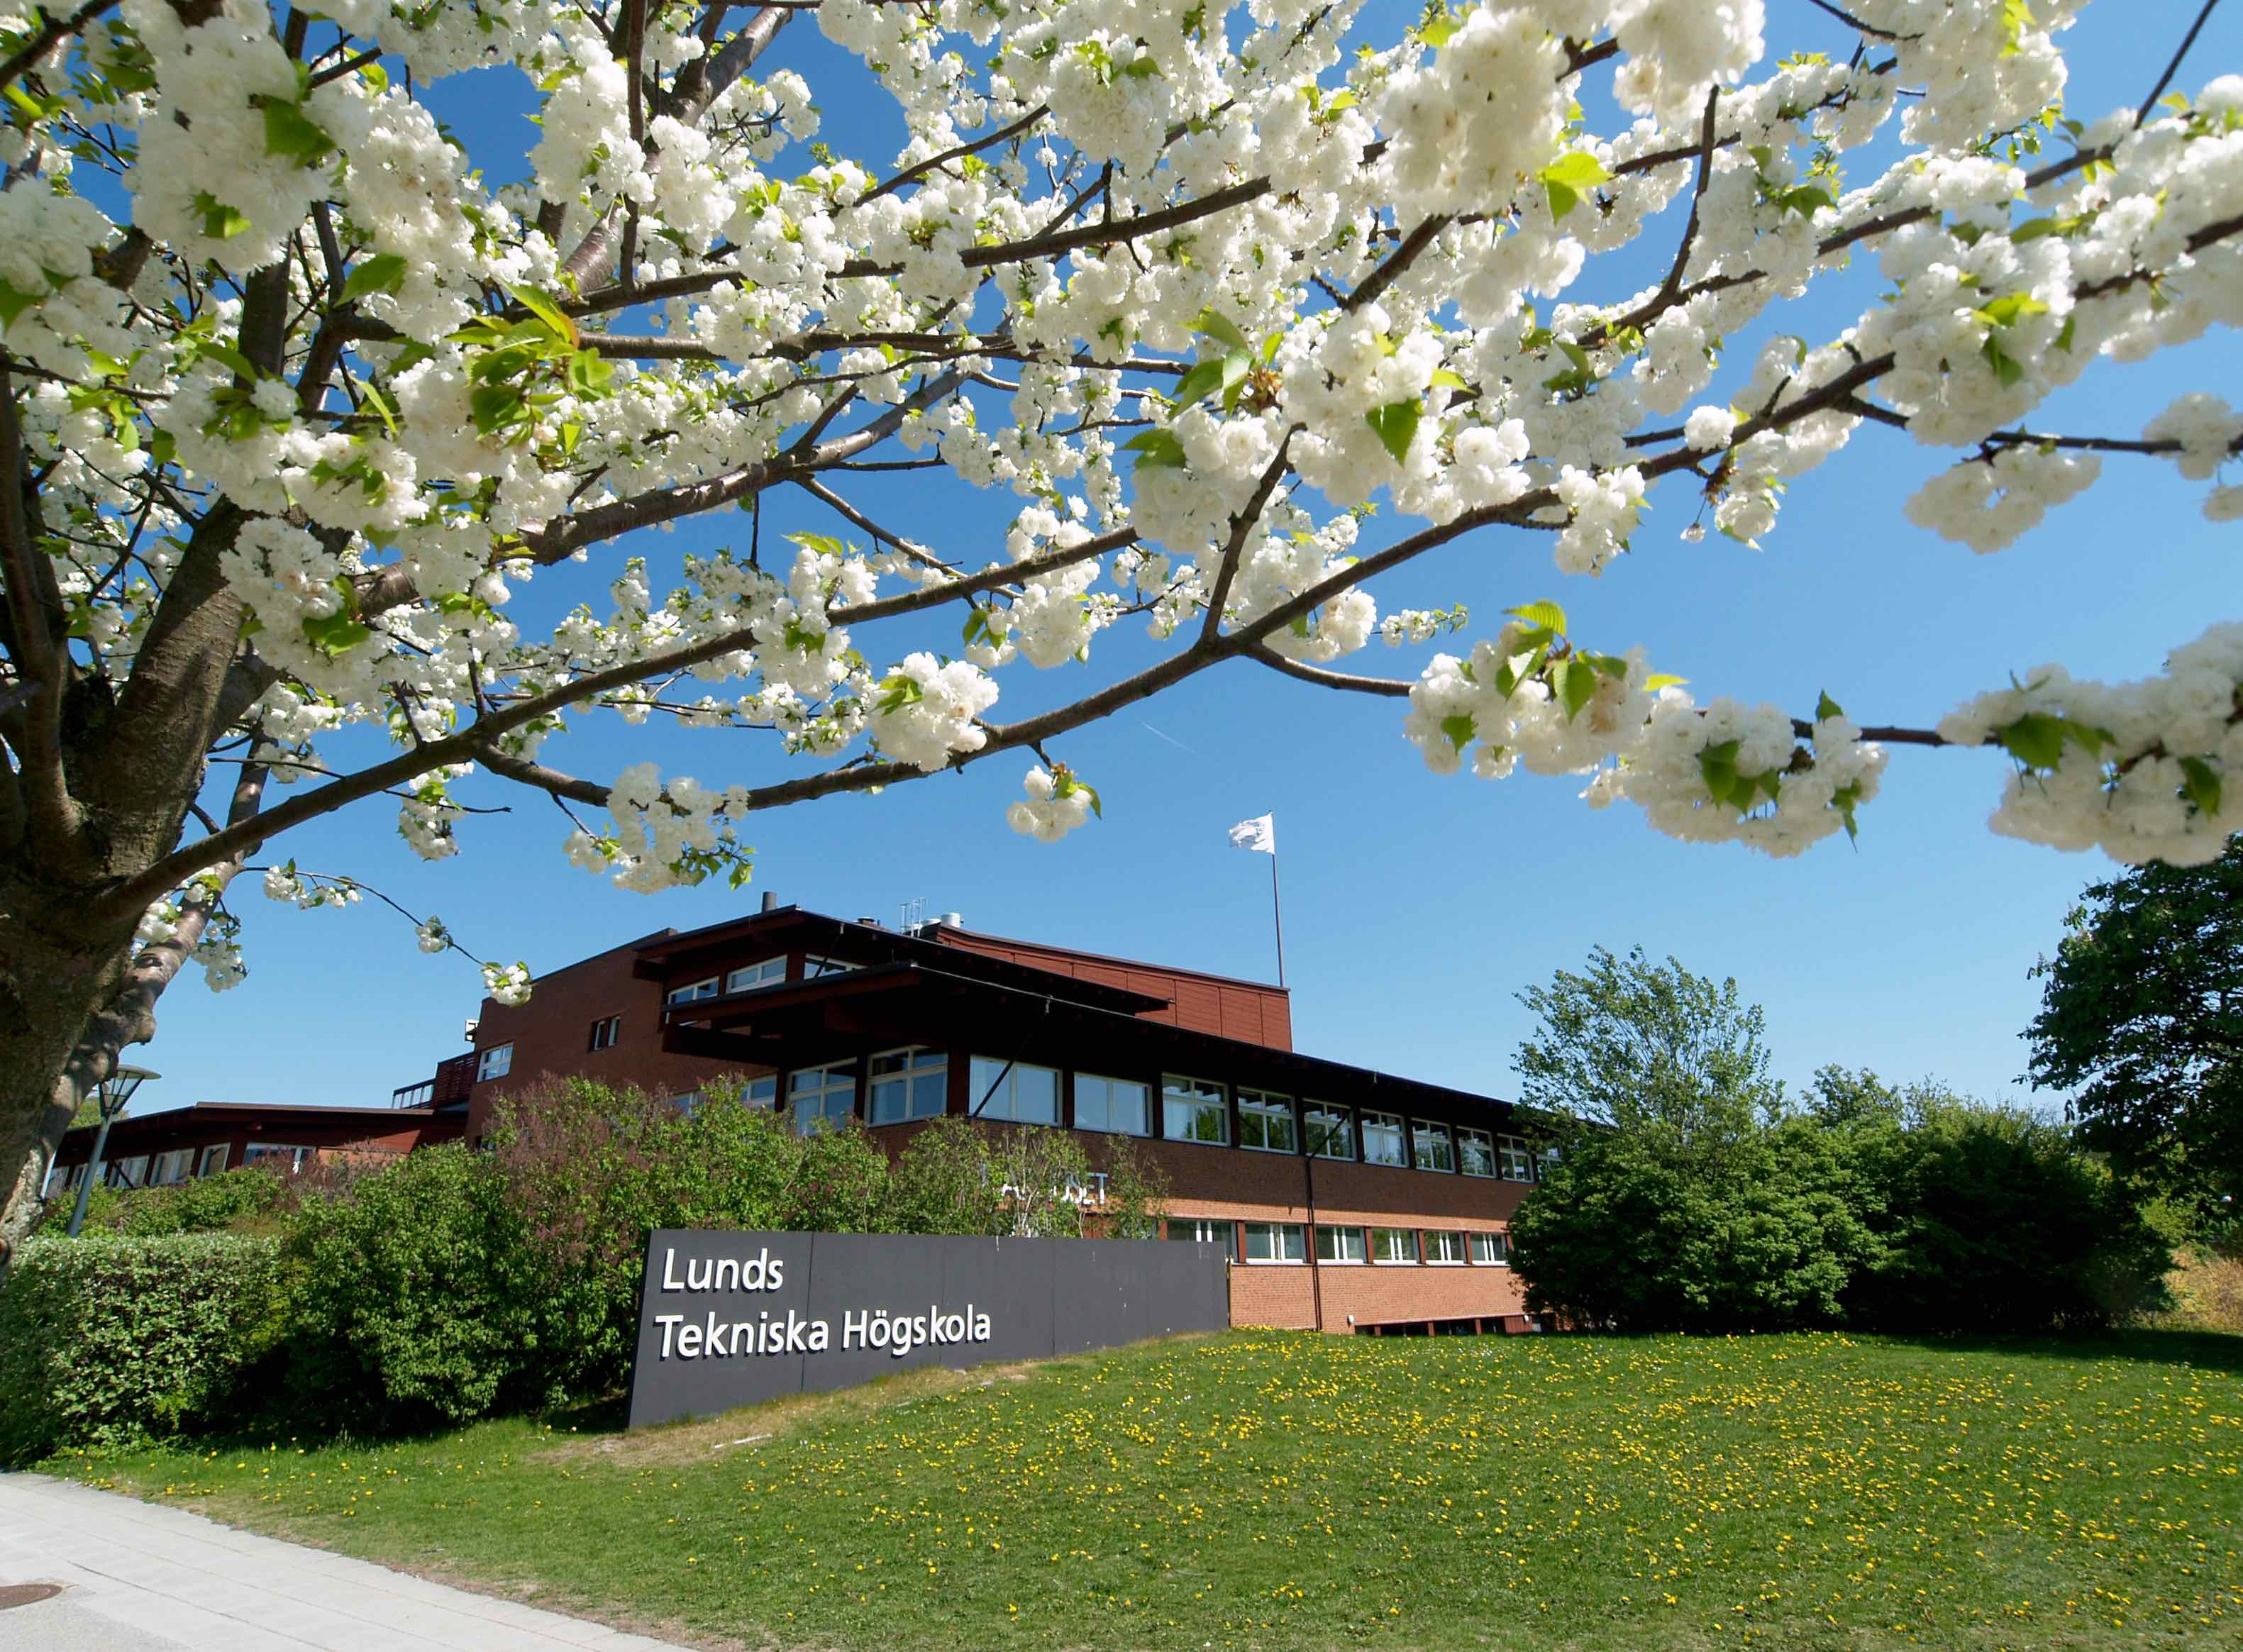
Fig. 1. Drawing | Fig. 2. Kårhuset LTH

summary and ACKNOWLEDGMENTS
Summary and acknowledgments are optional. The reference format is optional but has to be consistent (Vancouver, Harvard, …). The reference section shall be given as follows.
References
[1] | Lastname1, Initials, Lastname2, Initials, Lastname3, Initials and Lastname4, Initials (2009), Title of the article, Journal, Vol. 120, No. 6, pp. 1718-1731.
[2] | Lastname5, Initials (2006), Title of the article, Proc. of the Conference, Editors, Place of Conference, Vol. 2, pp. 120-128.
or
Lastname1, Initials., Lastname2, Initials., Lastname3, Initials. and Lastname4, Initials. (2009). Title of the article, Journal, Vol. 120, No. 6, pp. 1718-1731.
Lastname5, Initials. (2006). Title of the article, Proc. of the Conference, Editors, Place of Conference, Vol. 2, pp. 120-128.
or
. . .

